QUEZON CITY UNIVERSITY

## (Formerly Quezon City Polytechnic University)

**CERTIFICATE OF REGISTRATION AY: 2020-2021 SEM: 2nd**

1st Yr - SBIT1B

BSIT

# Campus: StudNo:

# San Bartolome 20-1900



## Course/Year/Section

Regular Student Irregular Student Graduating? Yes No

Date Enrolled: March 25, 2021

|  |  |  |
| --- | --- | --- |
| Ontangco | Jeramy Jon | Manaces |

## (Family Name) (Given Name) (Middle Name)

Enlisted by: REGULAR

Enrolled by: JERICO V. GALVEZ

|  |  |
| --- | --- |
| STUDENT ACCOUNT | Amount |
| Tuition Fee -20 Units @Php303.34/Unit | 6,066.80 |
| Library Fee | 100.00 |
| Registration | 200.00 |
| Comp/Major Lab | 500.00 |
| Student Council Fee | 40.00 |
| Athletics & Sports Dev. | 50.00 |
| Guidance Fee | 100.00 |
| Student Welfare | 50.00 |
| Cultural Fee | 100.00 |
| NSTP FEE | 100.00 |
| Medical & Dental | 50.00 |
| Development Fee | 400.00 |
| Total | **7,756.80** |

New Returnee

Old Transferee

Last Enrollment? Semester, School Yr 20 - 20 Course Previous University Course

|  |  |  |  |  |  |  |
| --- | --- | --- | --- | --- | --- | --- |
| **Code** | **Section-Subject** | **Unit** | **Room** | **Days** | **Time** | **Professor** |
| SCI 1 | SBIT1B-Science, Technology and Society | 3 | IB102a | F | 2:00PM-5:00PM | MAGDALAGA |
| GEE 3 | SBIT1B-Creative Practice: Tools, Methods and Techniques | 3 | IB102a | F | 6:00PM-9:00PM | PEÑA |
| CC103 | SBIT1B-Intermediate Programming | 3 | IB101a | T | 11:00AM-1:00PM |  |
| PE 2 | SBIT1B-Rhythmic Activities | 2 | SB OG | T | 3:00PM-5:00PM | BARROGA |
| CC103 | SBIT1B-Intermediate Programming | 0 | IB205b | T | 7:00AM-10:00AM |  |
| NET101 | SBIT1B-Networking 1 | 0 | IB202c | TH | 1:00PM-4:00PM |  |
| ENG 1 | SBIT1B-Purposive Communication | 3 | IB101a | TH | 5:00PM-8:00PM | AGUSTIN |
| NET101 | SBIT1B-Networking 1 | 3 | IB101a | TH | 9:00AM-11:00AM |  |
| PT101 | SBIT1B-Platform Technologies (Electives) | 0 | IB202c | W | 10:00AM-1:00PM |  |
| NSTP 2 | SBIT1B-National Service Training Program 2 | 3 | SB OG | W | 2:00PM-5:00PM | BECHAIDA |
| PT101 | SBIT1B-Platform Technologies (Electives) | 3 | IB101a | W | 7:00AM-9:00AM |  |

Total Units 23

Registration Date: March 25, 2021



ADVISER(Full Signature Over Printed Name) Student's Signature UNIVERSTIY REGISTRAR

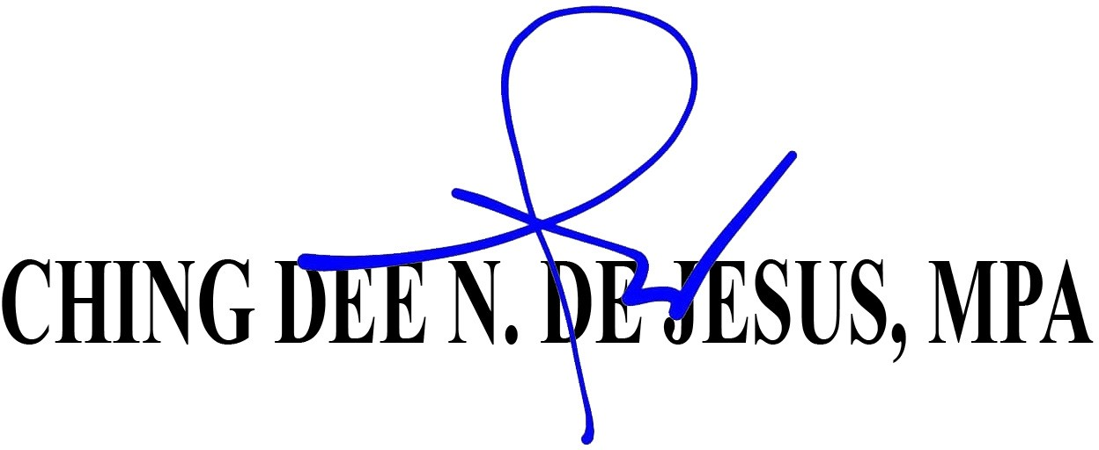

Graduation:

Only Students who have completed all requirements for graduation shall be allowed to graduate. These requirements include PE,NSTP and subjects by the University.

Students who complete their course requirements during the summer term or during the first semester shall be included in the next regular graduation rites. **Only students who apply for graduation during the designated application period shall be included in the list of Candidates for Graduation and the yearbook for the academic year.**